# Project Design Phase-II Technology Stack (Architecture & Stack)

|  |  |
| --- | --- |
| Date | 04November2022 |
| Team ID | PNT2022TMID01786 |
| Project Name | Data Analytics for DHL Logistics  Facilities |
| Maximum Marks | 4 Marks |

## Technical Architecture:

The Deliverable shall include the architectural diagram as below and the information as per the table1 & table 2

## Example: Order processing during pandemics for offline mode

**Reference:** [**https://developer.ibm.com/patterns/ai-powered-backend-system-for-order-processing-during-pandemics/**](https://developer.ibm.com/patterns/ai-powered-backend-system-for-order-processing-during-pandemics/)

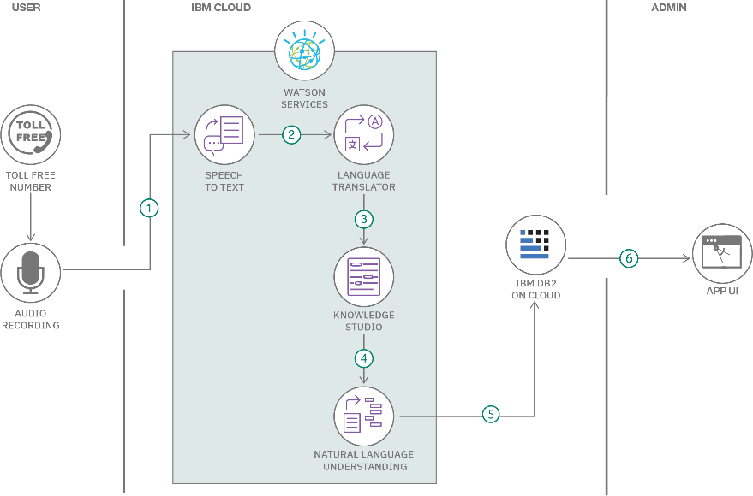

Guidelines:

1. Include all the processes (As an application logic / Technology Block)
2. Provide infrastructural demarcation (Local / Cloud)
3. Indicate external interfaces (third party API’s etc.)
4. Indicate Data Storage components / services
5. Indicate interface to machine learning models (if applicable)

# Table-1 : Components & Technologies:

|  |  |  |  |
| --- | --- | --- | --- |
| **S.No** | **Component** | **Description** | **Technology** |
| 1. | User Interface | User Uploads the CSV or Excel format files into the  Web Pages | HTML, CSS, JavaScript. |
| 2. | Application Logic-1 | The user data will pass into the IBM Cloud for  storage and act as a data source. | IBM Cloud |
| 3. | Application Logic-2 | In cloud data will be fetched by the cognos analytical  tool for data analysis | IBM Cognos analytical tool |
| 4. | Application Logic-3 | The Pre-trained dashboards will be present to  perform analysis on the incoming data. | IBM Cognos analytical tool |
| 5. | Database | Data will be retrieved from cloud. | MySQL. |
| 6. | Cloud Database | Database Service on Cloud | IBM DB2, IBM Cloud. |
| 7. | File Storage | Customer sales data is uploaded in cloud through  interface. | IBM Block Storage or Other Storage  Service or Local Filesystem |
| 8. | External API-1 | To perform data analysis on the user data. | IBM cognos Tool. |
| 9. | External API-2 | To built the machine learning model for  classification. | Jupiter Note book. |
| 10. | Machine Learning Model | To do the predictive analysis on the Input Data. | Predictive Analysis Model etc., |
| 11. | Infrastructure (Server / Cloud) | Application Deployment on Local System / Cloud Local Server Configuration: Using the Flask cloud server.  Cloud Server Configuration : IBM Cloud. | Local, Cloud Foundry |

**Table-2: Application Characteristics:**

|  |  |  |  |
| --- | --- | --- | --- |
| **S.No** | **Characteristics** | **Description** | **Technology** |
| 1. | Open-Source Frameworks | List the open-source frameworks used | Technology of Opensource framework |
| 2. | Security Implementations | List all the security / access controls implemented,  use of firewalls etc. | e.g. SHA-256, Encryptions, IAM  Controls, OWASP etc. |
| 3. | Scalable Architecture | Justify the scalability of architecture (3 – tier,  Micro-services) | Technology used |
| 4. | Availability | Justify the availability of application (e.g. use of  load balancers, distributed servers etc.) | Technology used |
| 5. | Performance | Design consideration for the performance of the  application (number of requests per sec, use of Cache, use of CDN’s) etc. | Technology used |